Nomenclature:
CAS: Crank Angle Synchronous
AI: Analog Input
DI: Digital Input
CAD: Crank Angle Degree

SCADA project
DATA LOGGING
Topic: DATA LOGGING  Author: C Guardiola, UPV  Date: 31/01/2024 | Reviewer:  Date:
OBJECTIVES:
- To provide a factual view of the system operation, including measurements, calculated values, and actuators.
- To log system operation.
- To accelerate the postprocessing and test analysis.
- To allow the postmortem analysis in case of errors triggering forced mode transitions (e.g. safety stop and venting) [TO BE VERIFIED]

GENERAL STRUCTURE: Figure 1 presents the general data flow structure, from acquisition to the stored files in the SSD disks connected to the two CRIO chassis. Whenever possible, all variables are propagated to the different files. Four files are generated:
A.1 Crank angle synchronous (CAS) instantaneous AI: in-cycle solved value of the fast CAS AI tasks.
A.2 Cycle averaged values, including relevant cylinder pressure and heat release calculation parameters. This file also includes the value of all time synchronous (TS) variables for every cycle.
A.3 Test averaged values (average, standard deviation, minimum and maximum values of the previous file).
B Time synchronous data logging.
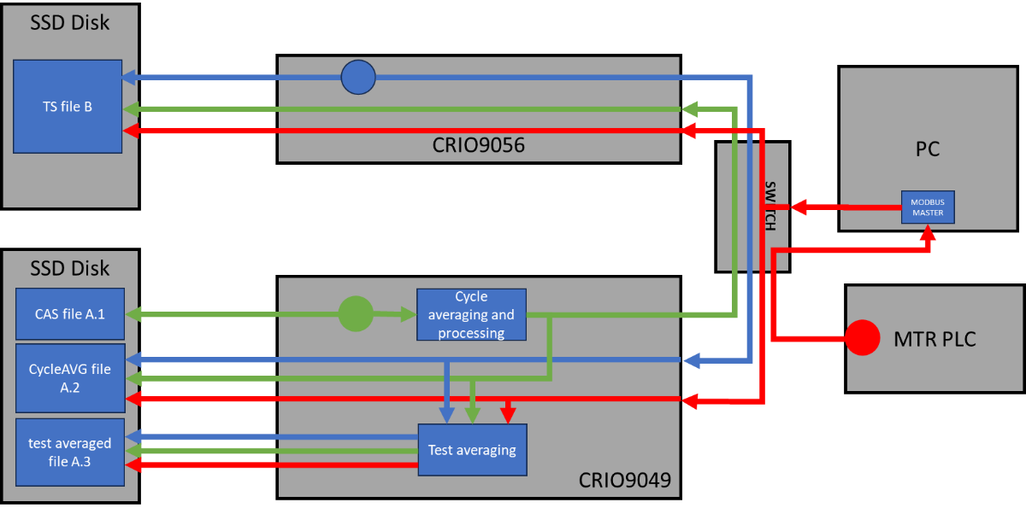
Figure 1. General data flow structure for the data logging. Red: variables from membrane controller; blue: time synchronous variables from CRIO905; green: crank angle synchronous variables from CRIO9049.

FILES and VARIABLE NAMING:
- CAS FILES
A.1. CAS instantaneous data file:
- Format: TDMS (.tdms). 1 file per test.
- Triggered by the test operator or by errors.
- In_cycle evolution of the signals, according to encoder resolution (e.g. 0.1 CAD/sample)
- Raw values (after sensor calibration) of the AI channels in the CAS mode
- Up to 1000 cycles. User can select a lower cycle number. 7200 rows per cycle (with 0.1 CAD/sample). Error triggered or pre_trigger recording mode always stored all data in buffer (max 1000 cycles).
- Automatic variable naming, pulled from configuration files.
- Automated file naming: APC_CRIO9049_DATE_HOUR_ TESTCODE_ID_CAS.tdms
(e.g. APC_CRIO9049_231010_103306_CO2swept_0013_CAS.tdms)

- Included signals: all CAS AI inputs (NI9222 cards):
SIGNALS in CAS AI | SIGNAL DEFINITION
Pcyl1_bar | E.g. Pressure within the main chamber of Cylinder #1, where the numbering of cylinders follows the convention outlined in the referenced document "Ref. Other document".
Pcyl2_bar
Pcyl3_bar
Pcyl4_bar
Pcyl5_bar
Pcyl6_bar
Ppre_bar
Psyst_bar
Pexh_bar

Note: 8 channels * 7200 floats * 1000 cycles >450 MB in TDMS (binary) format.
A.2. Cycle averaged file:
- Format: TDMS (.tdms). 1 file per test.
- Triggered by the test operator or by errors.
- Cycle averages of relevant variables: cylinder pressure metrics, combustion metrics, etc., plus value of the variables streamed from the time synchronous tasks (control settings, AI, etc.)
- Up to 1000 cycles. User can select a lower cycle number (see A.1). 1 row per cycle.
- Automatic naming extracted from a configuration files.
- File naming: APC_CRIO9049_DATE_HOUR_TESTCODE_ID_ CycleAVG.tdms
(e.g. APC_CRIO9049_231010_103306_CO2swept_0013_CycleAVG.tdms)

- Included signals:
CRIO9049 controls | CAS calculation results | CRIO9056 variables
TimeStamp9049_ms | WF_PT_012avg_bar | TimeStamp9056_ms
TimeStamp9056echo_ms | WF_PT_005avg_bar | SystemState_i8
InjectionState_b | IMEPg1_bar | WF_PT_001_bar
InjEnable_b | IMEPg2_bar | WF_OA_001_O2_perc
MainEnable_b | IMEPg3_bar | WF_OA_001_O2corr_perc
MainDuration_ms | IMEPg4_bar | WF_OA_001_Lambda_r
MainSOI_CADBTDC | IMEPg5_bar | WF_OA_002_O2_perc
SparkEnable_b | IMEPg6_bar | WF_OA_002_Lambda_r
SparkTiming_CADBTDC | IMEPn1_bar | WF_OA_002_NOx_ppm
 | IMEPn2_bar | EO_PT_001_bar
 | IMEPn3_bar | TORQUE_Nm
 | IMEPn4_bar | NI9205_9_V (channels not used)
 | IMEPn5_bar | NI9205_10_V
 | IMEPn6_bar | NI9205_11_V
 | PMEP1_bar | NI9205_12_V
 | PMEP2_bar | NI9205_13_V
 | PMEP3_bar | NI9205_14_V
 | PMEP4_bar | NI9205_15_V
 | PMEP5_bar | NG_FT_001_kgs
 | PMEP6_bar | NG_PT_001_bar
 | MaxPcyl1_bar | NGDI_PT_001_bar
 | MaxPcyl2_bar | O2_FC_001_kgs
 | MaxPcyl3_bar | NG_FC_001_kgs
 | MaxPcyl4_bar | NGDI_FT_001_kgs
 | MaxPcyl5_bar | WF_PT_004_bar
 | MaxPcyl6_bar | O2_PT_001_bar
 | IMEPstd1_bar | AR_PT_001_bar
 | IMEPstd2_bar | AR_FT_001_kgs
 | IMEPstd3_bar | WF_PT_016_bar
 | IMEPstd4_bar | WF_PT_014_bar
 | IMEPstd5_bar | SW_FT_001_kgs
 | IMEPstd6_bar | SW_FT_002_kgs
 | MAPO1_bar | SW_FT_003_kgs
 | MAPO2_bar | SW_FT_004_kgs
 | MAPO3_bar | WF_TT_001_degC
 | MAPO4_bar | O2_TT_001_degC
 | MAPO5_bar | AR_TT_001_degC
 | MAPO6_bar | NG_TT_001_degC
 | RI1 (placeholder for ringing intensity) | NGDI_TT_001_degC
 | RI2 | WF_TT_002 _degC
 | RI3 | WF_TT_003_degC
 | RI4 | WF_TT_004_degC
 | RI5 | WF_TT_007_degC
 | RI6 | PC_TT_001_degC
 | maxQ1_J | PC_TT_002_degC
 | maxQ2_J | PC_TT_003_degC
 | maxQ3_J | PC_TT_004_degC
 | maxQ4_J | PC_TT_005_degC
 | maxQ5_J | PC_TT_006_degC
 | maxQ6_J | EC_TT_001_degC
 | CA03_1_CADATDC | EC_TT_002_degC
 | CA03_2_CADATDC | SW_TT_001_degC
 | CA03_3_CADATDC | SW_TT_002_degC
 | CA03_4_CADATDC | SW_TT_003_degC
 | CA03_5_CADATDC | SW_TT_004_degC
 | CA03_6_CADATDC | SW_TT_005_degC
 | CA10_1_CADATDC | SW_TT_006_degC
 | CA10_2_CADATDC | SW_TT_007_degC
 | CA10_3_CADATDC | SW_TT_008_degC
 | CA10_4_CADATDC | SW_TT_009_degC
 | CA10_5_CADATDC | EO_TT_001_degC
 | CA10_6_CADATDC | EO_TT_002_degC
 | CA50_1_CADATDC | NI9214b_13_degC
 | CA50_2_CADATDC | NI9214b_14_degC
 | CA50_3_CADATDC | NI9214b_15_degC
 | CA50_4_CADATDC | NI9214b_16_degC
 | CA50_5_CADATDC | NI9264_AO0_V
 | CA50_6_CADATDC | NI9264_AO1_V
 | CA90_1_CADATDC | NI9264_AO2_V
 | CA90_2_CADATDC | NI9264_AO3_V
 | CA90_3_CADATDC | NI9264_AO4_V
 | CA90_4_CADATDC | NI9264_AO5_V
 | CA90_5_CADATDC | NI9264_AO6_V
 | CA90_6_CADATDC | NI9264_AO7_V
 | CA97_1_CADATDC | NI9264_AO8_V
 | CA97_2_CADATDC | NI9264_AO9_V
 | CA97_3_CADATDC | NI9264_AO10_V
 | CA97_4_CADATDC | NI9264_AO11_V
 | CA97_5_CADATDC | NI9264_AO12_V
 | CA97_6_CADATDC | NI9264_AO13_V
 | CA10CA90_1_CAD | NI9264_AO14_V
 | CA10CA90_2_CAD | NI9264_AO15_V
 | CA10CA90_3_CAD | O2_FC_001_REF_mA
 | CA10CA90_4_CAD | AR_PC_002_REF_mA
 | CA10CA90_5_CAD | NG_FC_001_REF_mA
 | CA10CA90_6_CAD | EC_FC_001_mA
 | maxdpdcad1_barCAD | SW_FC_004_REF_mA
 | maxdpdcad2_barCAD | SW_FC_009_mA
 | maxdpdcad3_barCAD | DYNO_REF_mA
 | maxdpdcad4_barCAD | NI9266_AO7_mA
 | maxdpdcad5_barCAD | NG_FV_001_b
 | maxdpdcad6_barCAD | O2_PV_004_b
 | kappa_comp1_r | AR_PV_004_b
 | kappa_comp2_r | WF_FC_001_b
 | kappa_comp3_r | WF_FC_002_b
 | kappa_comp4_r | WF_FC_003_b
 | kappa_comp5_r | NI9375_AO6_b
 | kappa_comp6_r | NI9375_AO7_b
 | kappa_exp1_r | NI9375_AO8_b
 | kappa_exp2_r | NI9375_AO9_b
 | kappa_exp3_r | NI9375_AO10_b
 | kappa_exp4_r | NI9375_AO11_b
 | kappa_exp5_r | NI9375_AO12_b
 | kappa_exp6_r | NI9375_AO13_b
 | CylPresWarnings_u64 | NI9375_AO14_b
 | CylPresErrors_u64 | NI9375_AO15_b
 |  | NI9375_AI0_b
 |  | NI9375_AI1_b
 |  | NI9375_AI2_b
 |  | NI9375_AI3_b
 |  | NI9375_AI4_b
 |  | NI9375_AI5_b
 |  | NI9375_AI6_b
 |  | NI9375_AI7_b
 |  | NI9375_AI8_b
 |  | NI9375_AI9_b
 |  | NI9375_AI10_b
 |  | NI9375_AI11_b
 |  | NI9375_AI12_b
 |  | NI9375_AI13_b
 |  | NI9375_AI14_b
 |  | NI9375_AI15_b
 |  | AIC103_CO2_ConcTarget_ack
 |  | AT103_CO2Conc
 |  | PV103_PressTarget_kPa_ack
 |  | PT103_Pressure_kPa
 |  | PV103_VlvPosTarget_pc_ack
 |  | PV103_VlvPos_pc_fb
 |  | AIC201_CO2_ConcTarget_ack
 |  | AT201_CO2Conc
 |  | FV301_FlowTarget_kgh_ack
 |  | FT301_Flow_kgh
 |  | FV301_VlvPosTarget_pc_ack
 |  | FV301_VlvPos_pc_fb
 |  | PV300_PressTarget_kPa_ack
 |  | PT300_Pressure_kPa
 |  | PV300_VlvPosTarget_pc_ack
 |  | PV300_VlvPos_pc_fb
 |  | C101_CompSpeed_rpm
 |  | PT104_Pressure_kPa
 |  | PT106_Pressure_kPa
 |  | PLC_Manual_Control
 |  | MTR_State
 |  | MTR_HeartBeat
 |  | PV103_Ctrl_Mode_act
 |  | FV301_Ctrl_Mode_act
 |  | PV300_Ctrl_Mode_act
 |  | MTR_Diagnostic_Status

A.3. Test averaged file:
- Format: ASCII (.txt). 1 file for testing campaign/day. Each recording generates 4 rows in the file.
- Triggered by the test operator or by errors.
- AVG, STD, MIN, MAX of the cycle values for the test.
- The results are added as 4 rows of a growing ASCII files. The following fields are created:
  - First columns of the file are:
ID: corresponds to the ID in CAS and CycleAVG files
Warning: 0 if the measurement is requested by the test operator. Error code if it is a file triggered by a system error.
Method: AVG, STD. MIN or MAX (note: a data filter in Excel serves for filtering the rows accordingly).
  - Next, the columns equivalent to those of the CycleAVG file are added (same naming convention).
  - Finally, three additional columns are added:
CAS file: name of related CAS file.
CycleAVG file: name of related CycleAVG file.
TEST NOTES: test notes added from the HMI by the operator.
- File naming: APC_CRIO9049_DATE_TESTCODE.txt
(e.g. APC_CRIO9049_231010_CO2swept.txt)
A new file is created if the test code is changed (e.g. different test campaign).
- Included signals:
Identification | Signals | Files and comments
ID | *ALL from CycleAVG file* | CA_ file
Warning |  | CycleAVG_file
Method |  | TEST_NOTES

- TS FILE
- Format: TDMS (.tdms). Automated streaming to disk. 1 file created on CRIO9056 startup.
- 10 Hz streaming of measured and calculated TS signals, together with the averaged CAS signals polled from the shared variables.
- File naming: APC_CRIO9056_DATE_HOUR_10Hz.txt
A single file is created on control system startup.
- Included signals:

CRIO9056 variables | Signals retrieved from MTR PLC | Signals retrieved from CRIO9049
TimeStamp9056_ms | AIC103_CO2_ConcTarget_ack | TimeStamp9049_ms
SystemState_i8 | AT103_CO2Conc | TimeStamp9056echo_ms
WF_PT_001_bar | PV103_PressTarget_kPa_ack | InjectionState_b
WF_OA_001_O2_perc | PT103_Pressure_kPa | InjEnable_b
WF_OA_001_O2corr_perc | PV103_VlvPosTarget_pc_ack | MainEnable_b
WF_OA_001_Lambda_r | PV103_VlvPos_pc_fb | MainDuration_ms
WF_OA_002_O2_perc | AIC201_CO2_ConcTarget_ack | MainSOI_CADBTDC
WF_OA_002_Lambda_r | AT201_CO2Conc | SparkEnable_b
WF_OA_002_NOx_ppm | FV301_FlowTarget_kgh_ack | SparkTiming_CADBTDC
EO_PT_001_bar | FT301_Flow_kgh | EngineSpeed_rpm
TORQUE_Nm | FV301_VlvPosTarget_pc_ack | WF_PT_012avg_bar
NI9205_9_V | FV301_VlvPos_pc_fb | WF_PT_005avg_bar
NI9205_10_V | PV300_PressTarget_kPa_ack | IMEPg1_bar
NI9205_11_V | PT300_Pressure_kPa | IMEPg2_bar
NI9205_12_V | PV300_VlvPosTarget_pc_ack | IMEPg3_bar
NI9205_13_V | PV300_VlvPos_pc_fb | IMEPg4_bar
NI9205_14_V | C101_CompSpeed_rpm | IMEPg5_bar
NI9205_15_V | PT104_Pressure_kPa | IMEPg6_bar
NG_FT_001_kgs | PT106_Pressure_kPa | IMEPn1_bar
NG_PT_001_bar | PLC_Manual_Control | IMEPn2_bar
NGDI_PT_001_bar | MTR_State | IMEPn3_bar
O2_FC_001_kgs | MTR_HeartBeat | IMEPn4_bar
NG_FC_001_kgs | PV103_Ctrl_Mode_act | IMEPn5_bar
NGDI_FT_001_kgs | FV301_Ctrl_Mode_act | IMEPn6_bar
WF_PT_004_bar | PV300_Ctrl_Mode_act | PMEP1_bar
O2_PT_001_bar | MTR_Diagnostic_Status | PMEP2_bar
AR_PT_001_bar |  | PMEP3_bar
AR_FT_001_kgs |  | PMEP4_bar
WF_PT_016_bar |  | PMEP5_bar
WF_PT_014_bar |  | PMEP6_bar
SW_FT_001_kgs |  | MaxPcyl1_bar
SW_FT_002_kgs |  | MaxPcyl2_bar
SW_FT_003_kgs |  | MaxPcyl3_bar
SW_FT_004_kgs |  | MaxPcyl4_bar
WF_TT_001_degC |  | MaxPcyl5_bar
O2_TT_001_degC |  | MaxPcyl6_bar
AR_TT_001_degC |  | IMEPstd1_bar
NG_TT_001_degC |  | IMEPstd2_bar
NGDI_TT_001_degC |  | IMEPstd3_bar
WF_TT_002 _degC |  | IMEPstd4_bar
WF_TT_003_degC |  | IMEPstd5_bar
WF_TT_004_degC |  | IMEPstd6_bar
WF_TT_007_degC |  | MAPO1_bar
PC_TT_001_degC |  | MAPO2_bar
PC_TT_002_degC |  | MAPO3_bar
PC_TT_003_degC |  | MAPO4_bar
PC_TT_004_degC |  | MAPO5_bar
PC_TT_005_degC |  | MAPO6_bar
PC_TT_006_degC |  | RI1
EC_TT_001_degC |  | RI2
EC_TT_002_degC |  | RI3
SW_TT_001_degC |  | RI4
SW_TT_002_degC |  | RI5
SW_TT_003_degC |  | RI6
SW_TT_004_degC |  | maxQ1_J
SW_TT_005_degC |  | maxQ2_J
SW_TT_006_degC |  | maxQ3_J
SW_TT_007_degC |  | maxQ4_J
SW_TT_008_degC |  | maxQ5_J
SW_TT_009_degC |  | maxQ6_J
EO_TT_001_degC |  | CA03_1_CADATDC
EO_TT_002_degC |  | CA03_2_CADATDC
NI9214b_13_degC |  | CA03_3_CADATDC
NI9214b_14_degC |  | CA03_4_CADATDC
NI9214b_15_degC |  | CA03_5_CADATDC
NI9214b_16_degC |  | CA03_6_CADATDC
NI9264_AO0_V |  | CA10_1_CADATDC
NI9264_AO1_V |  | CA10_2_CADATDC
NI9264_AO2_V |  | CA10_3_CADATDC
NI9264_AO3_V |  | CA10_4_CADATDC
NI9264_AO4_V |  | CA10_5_CADATDC
NI9264_AO5_V |  | CA10_6_CADATDC
NI9264_AO6_V |  | CA50_1_CADATDC
NI9264_AO7_V |  | CA50_2_CADATDC
NI9264_AO8_V |  | CA50_3_CADATDC
NI9264_AO9_V |  | CA50_4_CADATDC
NI9264_AO10_V |  | CA50_5_CADATDC
NI9264_AO11_V |  | CA50_6_CADATDC
NI9264_AO12_V |  | CA90_1_CADATDC
NI9264_AO13_V |  | CA90_2_CADATDC
NI9264_AO14_V |  | CA90_3_CADATDC
NI9264_AO15_V |  | CA90_4_CADATDC
O2_FC_001_REF_mA |  | CA90_5_CADATDC
AR_PC_002_REF_mA |  | CA90_6_CADATDC
NG_FC_001_REF_mA |  | CA97_1_CADATDC
EC_FC_001_mA |  | CA97_2_CADATDC
SW_FC_004_REF_mA |  | CA97_3_CADATDC
SW_FC_009_mA |  | CA97_4_CADATDC
DYNO_REF_mA |  | CA97_5_CADATDC
NI9266_AO7_mA |  | CA97_6_CADATDC
NG_FV_001_b |  | CA10CA90_1_CAD
O2_PV_004_b |  | CA10CA90_2_CAD
AR_PV_004_b |  | CA10CA90_3_CAD
WF_FC_001_b |  | CA10CA90_4_CAD
WF_FC_002_b |  | CA10CA90_5_CAD
WF_FC_003_b |  | CA10CA90_6_CAD
NI9375_AO6_b |  | maxdpdcad1_barCAD
NI9375_AO7_b |  | maxdpdcad2_barCAD
NI9375_AO8_b |  | maxdpdcad3_barCAD
NI9375_AO9_b |  | maxdpdcad4_barCAD
NI9375_AO10_b |  | maxdpdcad5_barCAD
NI9375_AO11_b |  | maxdpdcad6_barCAD
NI9375_AO12_b |  | kappa_comp1_r
NI9375_AO13_b |  | kappa_comp2_r
NI9375_AO14_b |  | kappa_comp3_r
NI9375_AO15_b |  | kappa_comp4_r
NI9375_AI0_b |  | kappa_comp5_r
NI9375_AI1_b |  | kappa_comp6_r
NI9375_AI2_b |  | kappa_exp1_r
NI9375_AI3_b |  | kappa_exp2_r
NI9375_AI4_b |  | kappa_exp3_r
NI9375_AI5_b |  | kappa_exp4_r
NI9375_AI6_b |  | kappa_exp5_r
NI9375_AI7_b |  | kappa_exp6_r
NI9375_AI8_b |  | CylPresWarnings_u64
NI9375_AI9_b |  | CylPresErrors_u64
NI9375_AI10_b
NI9375_AI11_b
NI9375_AI12_b
NI9375_AI13_b
NI9375_AI14_b
NI9375_AI15_b

ADDITIONAL NOTES:
- Variable names are stored in files unique for the project, so that the variable name is automatically propagated to the different chassis.
- Names automatically replace ‘-‘ by ‘_’, in order to make the use robust for Matlab
- Variables include unit at the end of the name. This is done automatically for the AI channels, and manually when declaring the variable name in the rest of cases. An exception to this naming are variables from MTR PLC.
_bar pressure in bar
_r ratio (-)
_perc percentage (%)
_kgs mass flow in kg/s
_degC temperature in ºC
_b boolean
_J energy in Joule
_CADATDC crank angle degrees before top dead center
_CADBTDC crank angle degrees after top dead center
_CAD crank angle degrees
_barCAD pressure increase rate bar/CAd
_ms time in ms
_mA current in mA
_V voltage in V

- Scripts and functions for loading TDMS in Matlab and Python are provided.
- HMI allows to trigger the data logging, and to input test notes.
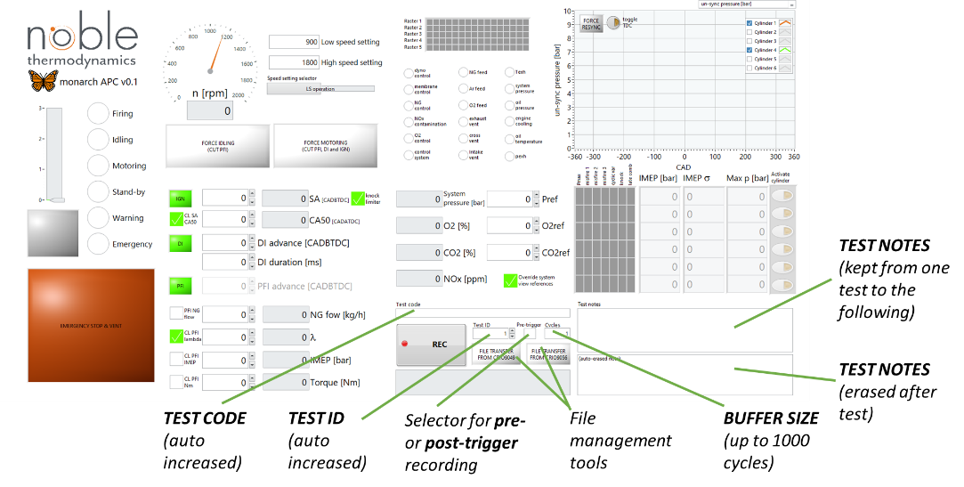
Figure 2. View of the user interface for the file recording.

